Basic objective for successful viable fermentation process
Industrial fermentation contains improved biochemical or physiological fermentation processes that are mainly carried out by fungi and bacteria on large scale to produce commercial products or to carry out important chemical transformations.
The main objective of industrial fermentation is to produce highest quality and quantity of a particular product by combining the works of different disciplines such as microbiology, biochemistry, genetics, chemistry, chemical and bioprocess engineering, mathematics, and computer science. Industrial fermentation is used in many industries, including microbiology, food, pharmaceutical, biotechnology, and chemical. Besides it is performed in large scale fermenters often as several thousand liters in volume. Industrial fermentation has different production targets such as microflora and primary or secondary metabolites production. These products, obtained through fermentation, have the potential to be used in a wide range of fields from the food industry to the pharmaceutical industry.
However, the application of fermentation at industrial level often has several limitations that limit its application, sustainability, and economic feasibility. Substrate used in fermentation process could limit the process performance due to purity of the substrate. A wide variety of substrates such as glucose, glycerol, sugar cane and molasses, coffee, and corn can be used as substrates in the fermentation process. But the purity and sterilization of the substrate used are quite important for the unproblematic operation of the fermentation process. The substrate is also one of the important cost items of the fermentation process. Another issue that increases the cost in fermentation process is the microbial culture purity and pathway. Chemicals such as vitamins and minerals are added to the anaerobic media to obtain the highest yields from microbial culture and to maintain purity, and all these ingredients contribute a serious cost to the overall cost of production. Another obstacle is pH, but this problem can be controlled by the addition of acid or base, even though it causes ion accumulation in the environment. Moreover, fermentation product may be difficult to remove from the medium. Frequently product may inhibit microbial growth and metabolism.
A fermentation product is produced by the culture of a certain organism, or animal cell line, in a nutrient medium. If a foreign microorganism invades the fermentation then the following consequences may occur:
- The medium would have to support the growth of both the production organism and the contaminant, resulting in a loss of productivity.
- If the fermentation is a continuous one then the contaminant may “outgrow” the production organism and displace it from the fermentation.
- The foreign organism may contaminate the final product, for example, single-cell protein where the cells, separated from the broth, constitute the product.
- The contaminant may produce compounds that make subsequent extraction of the final product difficult.
- The contaminant may degrade the desired product; this is common in bacterial contamination of antibiotic fermentations where the contaminant would have to be resistant to the normal inhibitory effects of the antibiotic and degradation of the antibiotic is a common resistance mechanism, for example, the degradation of β-lactam antibiotics by β-lactamase-producing bacteria.
- Contamination of a bacterial fermentation with phage could result in the lysis of the culture.

Avoidance of contamination may be achieved by:
- Effective design and construction of the fermentation plant.
- Using a pure inoculum to start the fermentation
- Sterilizing the medium to be employed.
- Sterilizing the fermenter vessel.
- Sterilizing all materials to be added to the fermentation during the process, for example, air, nutrient feeds, antifoams, and pH titrants.
- Maintaining aseptic conditions during the fermentation.
- Putting in place detailed operating procedures for sterilization, aseptic maintenance, and staff training.

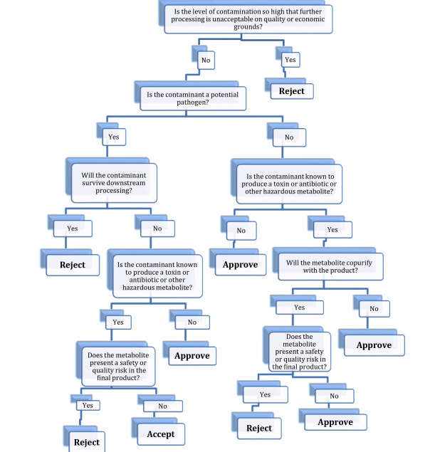

Fig 1. Decision flow chart for processing contaminated fermentation
References
- https://www.sciencedirect.com/topics/engineering/product-fermentation
- https://www.sciencedirect.com/topics/engineering/industrial-fermentation

